All-cause Hospitalization after nephrectomy Among Live Kidney Donors: Results from the WHOLE Donor Study

Amy Chang MD1*, Mary Grace Bowring MPH2*, Alain H Phung1, Jennifer L Alejo MD1, Indraneel Massie1, Laura B Zeiser MSc3, Shivani S Bisen BA3, Macey L Levan PhD3, Carolyn N Sidoti BS3, Jamie Locke MD PhD, Dorry L Segev MD PhD3, Elizabeth A King MD PhD1, Fawaz Al Ammary MD PhD4, Allan B Massie PhD3, Abimereki D Muzaale MD MPH1

*First authors contributed equally

(1) Department of Surgery, Johns Hopkins University School of Medicine, Baltimore MD

(2) Department of Biomedical Engineering, Johns Hopkins University School of Medicine, Baltimore MD

(3) Department of Surgery, New York University Grossman School of Medicine, New York NY  
(4) Department of Medicine, University of California Irvine School of Medicine, Irvine CA

WORD COUNT: 2603 (Limit 3000 [abstract+text])

ADDRESS FOR CORRESPONDENCE

Abimereki D Muzaale, MD MPH

Assistant Professor of Surgery, Department of Surgery

Johns Hopkins University School of Medicine

2000 E Monument St

Baltimore, MD 21205

[muzaale@jhmi.edu](mailto:muzaale@jhmi.edu)

ABBREVIATIONS

95%CI– 95% confidence interval

CVD—cardiovascular disease

BMI— body mass index  
ESRD— end-stage renale disease  
ICD-10— international classification of disease, tenth revision

IQR– interquartile range

LKD– live kidney donor   
OPTN – Organ Procurement and Transplantation Network

HR– hazard ratio

SRTR– The Scientific Registry of Transplant RecipientsABSTRACT (205/200 words)

Hospitalization may be a sentinel event signaling risk for adverse outcomes including end stage renal disease and mortality among live kidney donors (LKDs). However, only two years of follow-up are mandated for LKDs preventing long term risk characterization in this population. To address this, we used a XX-year multicenter retrospective cohort study of LKDs with xxx years of follow up to identify factors associated with patient-reported all-cause hospitalization. Patient factors were captured from self-report and the SRTR. From among an entire cohort of xxxx, 2251 LKDs that donated between 05/1968-12/2019 responded to the survey. Overall, x (x%) reported any hospitalization a median (interquartile range) of xx (x-x) years post-nephrectomy with surgery/procedure as the most common cause (57%). The cumulative incidence of hospitalization was 5%, 34%, 50%, and 61% at 1 ,10, 15, and 20-years post-donation. In a parsimonious model, age at donation (aHR 1.011.131.27, p=0.04), female sex (aHR 1.071.391.80, p=0.01), and post-donation diabetes/hypertension (aHR 1.221.521.88, p<0.01) were associated with hospitalization. While self-reported, the frequency of hospitalization among LKDs beyond 2-years post-nephrectomy suggests longer follow-up may be warranted for this population. Furthermore, surveillance and follow-up should be emphasized in populations at higher risk of developing diabetes and hypertension after nephrectomy.

INTRODUCTION

More than 6,400 living kidney donors (LKD) underwent transplants in 2022, but the downstream health effects of living donation remain elusive.(1) Currently, the mandated follow-up time for LKD is two years, but the adverse outcomes, such as end-stage renal disease (ESRD), cardiovascular disease (CVD), and mortality, are likely to manifest much later. (2-6) Anjum et al reported an eight-fold higher incidence rate ratio of late diagnosis of ESRD secondary to diabetes (≥10 years post-donation) compared to early diagnosis (<10 years post-donation), and the incidence rate ratio was three times higher for late diagnosis of ESRD secondary to hypertension. (7) Furthermore, LKDs have a 64% greater absolute risk of developing hypertension at 10 years post-donation compared to matched controls, which is closely linked to diabetes, cardiovascular disease, and is one of the leading causes of ESRD. (8, 9) Since the time to develop and detect these major outcomes is late, hospitalization may be a sentinel event that signals risk of adverse outcomes.

Currently, there are only two studies that reported on hospitalization. First, Garg et al reported a 31 hospitalizations event per 1000 person years that was not statistically significantly compared a healthy control.(9) Second, Schold et al reported a 9% cumulative incidence of all-cause hospitalization among live donors at three-years post-donation nephrectomy. Additionally, they found that higher hospitaliation rates were associated with older age, African American race, depression, hypothyroidism, and longer initial hospitalization. (10) However, there are no studies on hospitalization beyond six years. Therefore, to evaluate the all-cause post-donation hospitalization among LKD, this study aimed to assess the prevalence, causes, and risk factors of hospitalization following living kidney donation.

METHODS

**Data source**

The current study uses data from the Wellness and Health Outcomes of Live Donors (WHOLE-Donor) project, a multicenter cohort study on donors who underwent live donor nephrectomy at Johns Hopkins, University of Maryland, University of Alabama, Medstar Georgetown, Virginia Commonwealth University, University of Illinois, or Northwestern University. Eligibility included live kidney donors who were ≥2 years post-donation. International or Non-English-speaking donors were excluded. From 01/2011 – 05/2022, a total of 6927 eligible donors were actively recruited via phone, email, or mail using contact information provided by the transplant centers or LexisNexis Accurint. Donors provided informed consent and completed a survey that evaluated the donor’s demographic, medical history, hospitalization, and quality of life. Surveys were distributed every 2 years after consent for a total of up to 5 surveys. Our study population included a subgroup (2251/6926 [33%]) of donors who consented and answered the survey question regarding hospitalization status. Additionally, donors consented for the WHOLE-Donor team to contact the donor’s medical provider for laboratory results and medical records.

WHOLE-Donor dataset was linked with the Scientific Registry of Transplant Recipients (SRTR) dataset using date of donation, transplant center, sex, and age at donation. Overall xx% of our study population were identified in SRTR using these variables. Median household income was estimated using the 2021 American Community Survey dataset from the US Census Bureau ([www.census.gov](http://www.census.gov/)) by matching census tract GEOID. (11) WHOLE-Donor dataset was also linked with an Area Deprivation Index (ADI), a publicly accessible and validated neighborhood socioeconomic disadvantage metric formulated by the University of Wisconsin Neighborhood Atlas that combines 17 indicators, using the census block group GEOID. (12, 13) Participants provided informed consent. The Institutional Review Board approved this study (NA_00044282 & NA_00042871).

**Study population**

The source population included 6927 eligible donors who were at least two-years post-donation, and our study population included 2251 (33%) donors who responded to the survey question about hospitalization status. The median (interquartile range [IQR]) time to survey was 11 (6-16) years post-donation. The 2251 donors who were included in our study population were older, female, and Non-Hispanic White, but other characteristics were not clinically different compared to donors who did not respond to the hospitalization survey (Supplemental Table 1). Demographic, medical history, smoking history, and hospitalization status were collected via survey. Vital signs and laboratory results were collected via medical records from donor’s medical providers.

**Outcome of all-cause post-donation hospitalization**

The main outcome of all-cause post-donation hospitalization was defined as a positive response to the question, “Since your donation, have you been admitted to the hospital?” Among those who provided a positive response, the year, frequency, and cause for hospitalization were assessed (Supplemental Figure 1). The causes for hospitalization, which included self-reported free-text symptoms, diagnoses, surgeries or procedures, were classified by a single author (AC) using the International Classification of Disease, Tenth Revision (ICD-10) codes. The ICD-10 codes were then categorized into organ system/specialty (Supplemental Figure 2). Delivery (e.g. cesarian-section) was categorized separately from pregnancy-related hospitalization (e.g. ectopic pregnancy).

**Pre-donation factors associated with hospitalization**

Due to the exploratory nature of this project, we included a broad range of pre-donation factors in our analysis: age at donation, sex, race, education, smoking history, household income, area deprivation index, hypertension, vital signs (systolic and diastolic blood pressure, body mass index [BMI]), estimated glomerular filtration rate (eGFR). Less than 1% of our study population had pre-donation diabetes, so this was not included. Age, body mass index (BMI), systolic and diastolic blood pressure, eGFR, and household income were included in the model as continuous variables. Monoracial categories of Hispanic, Non-Hispanic White, Black, and other were captured using WHOLE-Donor surveys. (14) Due to the small proportion of LKDs who identified as Asian, Alaskan Native/American Indian, multiracial or other, these categories were consolidated as Non-Hispanic Other. Our analyses used ADI as a binary variable; high ADI was defined as an ADI above the median of the study population. CKD-EPI creatinine equation 2021 was used to calculate the eGFR.

**Post-donation factors associated with hospitalization**

Post-donation diabetes and hypertension diagnosis and year of diagnosis were captured using WHOLE-Donor (Supplemental Figure 1) and SRTR data defined as a new diagnosis post-donation and before hospitalization.

**Statistical analysis**

We used Kaplan-Meier methods with a time scale of years from the time of donation and followed patients until the reported year of hospitalization or survey completion date. Patients that reported hospitalization but did not report the year of hospitalization were excluded (n=72). Patients were followed until the first self-reported hospitalization or survey date. Multivariable Cox regression model was used to identify pre-donation risk factors associated with hospitalization. The final variables that were included in the model were selected based on Akaike’s Information Criteria. (15) To determine whether the role of ADI varied by donor race, we tested the interaction between race/ethnicity and ADI above/below the median in our study population. (16, 17) A second multivariable Cox regression model was used to evaluate the association of post-donation diagnoses (diabetes and hypertension), as a time dependent variable, with hospitalization. Additionally, a parsimonious Cox regression model, adjusting for age at donation, sex, smoking history, and race, was also reported to evaluate the association of post-donation diagnoses. (18) All two-sided p-values <0.05 were considered statistically significant. Analysis was performed using Stata version 17.0/SE for Linux (StataCorp).

RESULTS

**Study population**

Our study included 2251 LKD who underwent live donor nephrectomy between 05/1968 and 12/2019. The median age at donation was 47(38-55) years; 1495 (66%) were female, and 1746(81%) were Non-Hispanic White. In terms of pre-donation medical history, few LKDs reported hypertension (6%) or diabetes (<1%). The median BMI was 27(24-30) kg/m2. Median systolic and diastolic blood pressure was 123(114-132) mmHg and 73(68-80) mmHg respectively. Median eGFR was 95(83-107) mL/min/1.73m2. In terms of social history, 93% had insurance at the time of donation, and 40% reported ever smoking tobacco. The median household income was $81,774(61,058-113,700) U.S. dollars. Most were college-educated (57%). The median ADI was 38(20-60)% (Table 1).

**All-cause post-donation hospitalization and causes**

Over a median follow-up of 11(6-16) years, 938(42%) reported at least one hospitalization, with the first hospitalization reported at a median of 7(3-12) years post-donation. The median frequency of hospitalization was 1(1-2).

Of the 938 LKDs, 895(95%) specified a cause for hospitalization, with 57% reporting that the hospitalization was related to a procedure or surgery of any specialty. When categorizing the causes by organ system/specialty, the most frequently reported causes were related to musculoskeletal (23%), followed by gastrointestinal (21%), cardiovascular (20%). Less frequently reported causes were female genitourinary (10%), neurologic (10%), urology/nephrology (7%), delivery/cesarean section (6%), hernia (5%), neoplasm (5%), endocrine (4%), breast (4%), ear, nose and throat (4%), respiratory (4%), and infectious disease (2%). The least frequently reported were psychiatric (1%), pregnancy (1%), hematology (1%), fall (1%), dermatology (1%), male genitourinary (1%), and post-operative complication (1%) (Table 2).

**Cumulative incidence of hospitalization**

In a time-to-event framework, the cumulative incidence of hospitalization at one, three, five, ten, fifteen, and twenty-years were 5%(95% confidence interval [CI]:4-5), 12%(95% CI:10-13), 18%(95% CI:16-20), 34%(95% CI:32-37), 50%(95% CI:47-53), and 61%(95% CI:58-65) respectively (Figure 1).

**Pre-donation factors associated with time to hospitalization**

Using multivariable Cox regression, we identified two pre-donation factors that were statistically significantly associated with time to hospitalization: age (adjusted hazard ratio [aHR] 1.011.131.27, p=0.04) and female sex (aHR 1.071.391.80, p=0.01) (Figure 2). As for other characteristics association with hospitalization: hypertension history (aHR 0.651.011.59, p=0.96), BMI (aHR 0.991.121.27, p=0.06), systolic blood pressure (aHR 0.880.971.07, p=0.53), diastolic blood pressure (aHR 0.971.131.31, p=0.11), ever-smoke (aHR0.811.021.29, p=0.85), eGFR (aHR 0.991.071.15, p=0.08), Hispanic (aHR 0.601.172.30, p=0.64),

Non-Hispanic Black (aHR 0.56­0.811.17, p=0.25), Non-Hispanic other (aHR 0.300.741.79, p=0.50), household income (aHR 0.930.971.00, p=0.10), not four-year college educated (aHR 0.770.971.22, p=0.79), insurance status (aHR 0.931.622.84, p=0.09), and high ADI (aHR 0.600.821.10, p=0.18). The role of ADI did not vary by donor race/ethnicity (p-interaction>0.24).

**Post-donation factors associated with hospitalization**

Overall, 3% had post-donation diagnoses of diabetes (0.7%) or hypertension (3%). In the Cox regression model adjusting for pre-donation factors, post-donation diagnoses were positively, but not statistically significantly, associated with hospitalization (aHR 0.901.301.88, p=0.16). In our parsimonious model, this positive relationship persisted between post-donation diagnoses and hospitalization, and was statistically significant (aHR 1.221.521.88, p<0.01). When comparing those who had missing variables to those who were not missing variables in the parsimonious model, demographic characteristics were clinically similar, with the exception of a longer follow-up time among those who had missing variables (15 vs 8 years between donation and last survey date) (Supplemental Figure 3 and 4).

DISCUSSION

In this multicenter cohort study of LKDs, half of LKDs reported hospitalization by 15 years post-donation. The leading cause of hospitalization was reported as any surgery or procedure (57%). Age at donation and female sex were statistically significantly associated with hospitalization. In a parsimonious Cox regression model, post-donation diagnoses of diabetes or hypertension were statistically significantly associated with hospitalization.

Our study found that the cumulative incidences at one- and three-years was approximately 5% and 12% respectively, which were similar to the reported cumulative incidence of 5% and 11 % among live kidney donors by Schold et al by the respective years. (10) Though Schold et al had a larger study population and specific dates of hospitalization, our study reported similar short-term cumulative incidences, and expanded the outcomes beyond three years post-donation. In this study, we found the cumulative incidences at five, ten, fifteen, and twenty-years to be approximately 18%, 34%, 50%, and 61% respectively. Our findings are also in agreement with the report from the National Center for Health Statistics, which found that 5.8% and 7.8% among people aged 18-44 and 45-64, respectively, reported a hospital stay over the past year in 2018. (19) However, without adjusting for health characteristics, it is difficult to compare the rate of hospitalization of donors with any control group that would be as healthy and fit.

We also found that older age at donation was associated with a 1.13 greater hazard of hospitalization, which was expected and consistent with reports from the general population .(20) Previous studies have shown that older donors have a reduction in nephron number and eGFR in the short term, but the risk of ESRD, cardiovascular disease, and mortality in the intermediate term is similar compared to healthy control or younger donors. (21-25) However, the insidious course of such adverse events may emerge beyond the respective study periods. Thus, hospitalization may be a surrogate measure of donor health status and remain an important risk to counsel older donors on, because hospitalization among older adults is associated with cognitive and functional impairments. (26-28) One study even reported a 122 greater hazard of any disability within five years after hospitalization among elderly patients who were not physically frail at baseline. (29)

Another risk factor for hospitalization was post-donation diagnoses of diabetes or hypertension. Sanchez et al reported that donors with post-donation hypertension had a greater hazard ratio of 1.77 and 1.55 of developing diabetes and proteinuria, respectively, compared to donors who never developed hypertension. (30) Since hypertension and diabetes are two of the leading causes of ESRD among live donors, it is imperative that donors are vigilant with follow-up, perhaps even encouraging home blood pressure monitoring. (31)

A few limitations should be mentioned. First, the observational study design is prone to significant loss to follow-up, and the survey-measured outcomes lends to recall bias. Second, the use of ICD-10 codes for cause of hospitalization may be incomplete, so we grouped the causes by system, despite losing granuarlity. Third, data missingness, especially with the diagnoses of diabetes and hypertension, may depreciate the generalizability of our findings. However, our large study population and use of a multivariable regression adjusts for these variances. Lastly, the lack of a healthy non-donor control group makes inferences difficult. Though we found a report of similar one-year hospitalization incidence in the general population, there was no information on pre-existing health conditions that would have precluded kidney donation. Additionally, there was no literature for the risk of healthy nondonors, so we cannot describe the nephrectomy-attributable rate of hospitalization, due to the challenges of finding an appropriate control group that has the same degree of highly selected health status and granular hospitalization data.

One of the strengths of this study is the long-term outcome with a median follow up of 11 (IQR 6-16) years between donation and last survey. Another strength of this study is the inclusion of social determinants of health, such as race and socioeconomic status, in our regression models. Though the interaction between race and neighborhood socioeconomic status was not statistically significant (p<0.24), Non-Hispanic Black race, Non-Hispanic other race, and disadvantaged neighborhood indexes were negatively associated with hospitalization, which may be related to structural barriers in access to healthcare, which has been well documented in the literature. (32)

In conclusion, older age at donation, female sex, and post-donation diagnoses of diabetes or hypertension were associated with greater risk of hospitalization after live kidney donation. Therefore, pre-donation counseling and post-donation vigilance should be emphasized.

ACKNOWLEDGMENTS

This work was supported by grant numbers T32GM136577 (MGB) from the National Institute of General Medical Sciences, T32DK007713 (JLA), 5K01DK114388-05 (MLL), K01DK101677 (ABM), K23DK129820 (FA) from the National Institute of Diabetes and Digestive and Kidney Diseases, K24AI144954-08 and 3U01AI138897-04S1 (DLS) from the National Institute of Allergy and Infectious Diseases, Johns Hopkins Catalyst Award (MLL), and Ben-Dov and Trokhan Patterson families.

The authors thank the participants of the Johns Hopkins Wellness and Health Outcomes of Live Donors (WHOLE-Donor) Study, without whom this research could not be possible. The WHOLE-Donor site principal investigators include Dr. Elizabeth A King (Johns Hopkins University), Drs. Jayme Locke and Rhiannon Reed (University of Alabama at Birmingham), Dr. Gaurav Gupta (Virginia Commonwealth University), Dr. Matthew Weir (University of Maryland), Drs. Matthew Cooper (Georgetown University), and Dr. John Friedewald (Northwestern University).

They also thank the members of the study team, including Sachin Mehta, Snigdha Panda BA, Ananda Thomas BA, Michael Irving BS, Samantha Getsin BS, Madeleine Waldram BS, Samantha Halpern BS, Austin Schmidt BA, Molly Ma BA, Jessica Semel BS, Rahul Daniel BS, Evan Lau BA, Angela Ramirez, and Faith Obilo. They also thank Diane Brown RN and Daniel S Warren PhD for project support and guidance.

DISCLOSURE

DL Segev received consulting fees from AstraZeneca, Novavax, Novartis, CareDx, Transmedics, CSL Behring, Jazz Pharmaceuticals, Veloxis, Mallinckrodt, and Thermo Fisher Scientific, lecture fees from Sanofi, AstraZeneca, Optum, CareDx, Novartis, and is a journal editor for Springer. ML Levan is a consultant for Takeda/Shire and Patients Like Me. The remaining authors of this manuscript have no financial disclosures or conflicts of interest to disclose.

The analyses described here are the responsibility of the authors alone and do not necessarily reflect the views or policies of the Department of Health and Human Services, nor does mention of trade names, commercial products or organizations imply endorsement by the U.S. Government. The data reported here have been supplied by the Hennepin Healthcare Research Institute (HHRI) as the contractor for the Scientific Registry of Transplant Recipients (SRTR). The interpretation and reporting of these data are the responsibility of the author(s) and in no way should be seen as an official policy of or interpretation by the SRTR or the U.S. Government.

REFERENCES

1. OPTN National Data Kidney Donor. 2023 April 02, 2023; Available from: [https://optn.transplant.hrsa.gov/data/view-data-reports/national-data/#](https://optn.transplant.hrsa.gov/data/view-data-reports/national-data/)

2. Berglund DM, Zhang L, Matas AJ, Ibrahim HN. Measured Glomerular Filtration Rate After Kidney Donation: No Evidence of Accelerated Decay. Transplantation 2018;102(10):1756-1761.

3. Muzaale AD, Massie AB, Wang MC, Montgomery RA, McBride MA, Wainright JL et al. Risk of end-stage renal disease following live kidney donation. Jama 2014;311(6):579-586.

4. Segev DL, Muzaale AD, Caffo BS, Mehta SH, Singer AL, Taranto SE et al. Perioperative mortality and long-term survival following live kidney donation. JAMA 2010;303(10):959-966.

5. Mjoen G, Hallan S, Hartmann A, Foss A, Midtvedt K, Oyen O et al. Long-term risks for kidney donors. Kidney Int 2014;86(1):162-167.

6. Ferro CJ, Townend JN. Risk for subsequent hypertension and cardiovascular disease after living kidney donation: is it clinically relevant? Clinical Kidney Journal 2021;15(4):644-656.

7. Anjum S, Muzaale AD, Massie AB, Bae S, Luo X, Grams ME et al. Patterns of End-Stage Renal Disease Caused by Diabetes, Hypertension, and Glomerulonephritis in Live Kidney Donors. Am J Transplant 2016;16(12):3540-3547.

8. Chaudry M, Gislason GH, Fosbøl EL, Køber L, Gerds TA, Torp-Pedersen C. Hypertension, cardiovascular disease and cause of death in Danish living kidney donors: matched cohort study. BMJ Open 2020;10(11):e041122.

9. Garg AX, Prasad GVR, Thiessen-Philbrook HR, Ping L, Melo M, Gibney EM et al. Cardiovascular Disease and Hypertension Risk in Living Kidney Donors: An Analysis of Health Administrative Data in Ontario, Canada. Transplantation 2008;86(3):399-406.

10. Schold JD, Goldfarb DA, Buccini LD, Rodrigue JR, Mandelbrot D, Heaphy EL et al. Hospitalizations following living donor nephrectomy in the United States. Clin J Am Soc Nephrol 2014;9(2):355-365.

11. Bureau USC. 2021 American Community Survey 5-Year Estimates: Median Income in the Past 12 Months. In. <https://www.census.gov/>: U.S. Census Bureau.

12. Kind AJH, Buckingham WR. Making Neighborhood-Disadvantage Metrics Accessible - The Neighborhood Atlas. N Engl J Med 2018;378(26):2456-2458.

13. University of Wisconsin School of Medicine and Public Health. In. 2020 Area Deprivation Index v3.2: Downloaded from <https://www.neighborhoodatlas.medicine.wisc.edu/> March 08, 2023.

14. Howell J, Emerson MO. So What “Should” We Use? Evaluating the Impact of Five Racial Measures on Markers of Social Inequality. Sociology of Race and Ethnicity 2017;3(1):14-30.

15. Akaike H. Likelihood of a model and information criteria. Journal of Econometrics 1981;16(1):3-14.

16. Strauss AT, Moughames E, Jackson JW, Malinsky D, Segev DL, Hamilton JP et al. Critical interactions between race and the highly granular area deprivation index in liver transplant evaluation. Clin Transplant 2023;37(5):e14938.

17. Diaz A, Valbuena VSM, Dimick JB, Ibrahim AM. Association of Neighborhood Deprivation, Race, and Postoperative Outcomes: Improvement in Neighborhood Deprivation is Associated With Worsening Surgical Disparities. Ann Surg 2022.

18. Lehr S, Schemper M. Parsimonious analysis of time-dependent effects in the Cox model. Stat Med 2007;26(13):2686-2698.

19. National Center for Health Statistics. Health US, 2019: Table 40. Hyattsville, MD. 2019. Available from: <https://www.cdc.gov/nchs/hus/data-finder.htm>.; Available from:

20. Hallgren J, Fransson EI, Kåreholt I, Reynolds CA, Pedersen NL, Dahl Aslan AK. Factors associated with hospitalization risk among community living middle aged and older persons: Results from the Swedish Adoption/Twin Study of Aging (SATSA). Archives of Gerontology and Geriatrics 2016;66:102-108.

21. Schuster A, Franke P, Steines L, Zecher D, Hackl C, Werner J et al. Safe Long-Term Outcome After Kidney Donation in Older Donors: A Single-Center Experience. Ann Transplant 2020;25:e924235.

22. Reese PP, Bloom RD, Feldman HI, Rosenbaum P, Wang W, Saynisch P et al. Mortality and cardiovascular disease among older live kidney donors. Am J Transplant 2014;14(8):1853-1861.

23. Tan JC, Busque S, Workeneh B, Ho B, Derby G, Blouch KL et al. Effects of aging on glomerular function and number in living kidney donors. Kidney Int 2010;78(7):686-692.

24. Toyoda M, Yamanaga S, Kawabata C, Hidaka Y, Inadome A, Arakane F et al. Long-term safety of living kidney donors aged 60 and older. Transplant Proc 2014;46(2):318-320.

25. Bellini MI, Nozdrin M, Pengel L, Knight S, Papalois V. Risks for donors associated with living kidney donation: meta-analysis British Journal of Surgery 2022;109(8):671-678.

26. Loyd C, Markland AD, Zhang Y, Fowler M, Harper S, Wright NC et al. Prevalence of Hospital-Associated Disability in Older Adults: A Meta-analysis. J Am Med Dir Assoc 2020;21(4):455-461.e455.

27. Skains RM, Zhang Y, Osborne JD, O'Leary T, Fowler ME, Markland A et al. Hospital-associated disability due to avoidable hospitalizations among older adults. J Am Geriatr Soc 2023;71(5):1395-1405.

28. Helvik AS, Selbæk G, Engedal K. Cognitive decline one year after hospitalization in older adults without dementia. Dement Geriatr Cogn Disord 2012;34(3-4):198-205.

29. Gill TM, Allore HG, Holford TR, Guo Z. Hospitalization, Restricted Activity, and the Development of Disability Among Older Persons. JAMA 2004;292(17):2115-2124.

30. Chen J, Bhattacharya S, Sirota M, Laiudompitak S, Schaefer H, Thomson E et al. Assessment of Postdonation Outcomes in US Living Kidney Donors Using Publicly Available Data Sets. JAMA Netw Open 2019;2(4):e191851.

31. Guirguis-Blake JM, Evans CV, Webber EM, Coppola EL, Perdue LA, Weyrich MS. Screening for Hypertension in Adults: Updated Evidence Report and Systematic Review for the US Preventive Services Task Force. Jama 2021;325(16):1657-1669.

32. Manuel JI. Racial/Ethnic and Gender Disparities in Health Care Use and Access. Health Serv Res 2018;53(3):1407-1429.

* (UNOFFICIAL REFERENCES LIST)  
  https://www.amjtransplant.org/article/S1600-6135(22)25054-0/fulltext
* Hsu https://pubmed.ncbi.nlm.nih.gov/19237717/
* Chang PY, Chien LN, Bai CH, Lin YF, Chiou HY. Continuity of care with physicians and risk of subsequent hospitalization and end-stage renal disease in newly diagnosed type 2 diabetes mellitus patients. Ther Clin Risk Manag. 2018;14:511-521. Published 2018 Mar 13. doi:10.2147/TCRM.S150638
* Health Quality Ontario. Continuity of care to optimize chronic disease management in the community setting: an evidence-based analysis. Ont Health Technol Assess Ser. 2013;13(6):1-41. Published 2013 Sep 1.
* Choi D, Choi S, Kim H, et al. Impact of continuity of care on cardiovascular disease risk among newly-diagnosed hypertension patients. Sci Rep. 2020;10(1):19991. Published 2020 Nov 17. doi:10.1038/s41598-020-77131-w
* Ibrahim Sejm 2009 living donors
* Feng et al 2022 BMC Med Res Methodol <https://www.ncbi.nlm.nih.gov/pmc/articles/PMC9758895/>

Table 1. Baseline demographic, health, and socioeconomic characteristics of live kidney donors among LKDs who were hospitalized versus never hospitalized.

|  |  |
| --- | --- |
|  | N=2251 |
| Age, y, median (IQR) | 47 (38-55) |
| Female, % | 66 |
| Race/Ethnicity |  |
| Non-Hispanic White, % | 81 |
| Hispanic (any race), % | 3 |
| Non-Hispanic Black, % | 14 |
| Non-Hispanic Othera, % | 2 |
| Hypertension History, % | 6 |
| Diabetes History, % | <1 |
| BMI, kg/m2, median (IQR) | 27 (24-30) |
| Systolic BP, mmHg, median (IQR) | 124 (114-133) |
| Diastolic BP, mmHg, median (IQR) | 74 (68-80) |
| eGFR, mL/min/1.73m2,median (IQR) | 95 (83-107) |
| Ever Smokeb, % | 40 |
| Had Insurance, % | 93 |
| Four Year Bachelor or above, % | 57 |
| Household Income, USD, median (IQR) | 81774 (61058-113700) |
| Area Deprivation Index, %, median (IQR) | 38 (20-60) |
| Center, % |  |
| Johns Hopkins | 38 |
| University of Maryland | 22 |
| University of Alabama | 16 |
| Northwestern | 10 |
| Virginia Commonwealth | 7 |
| Medstar Georgetown | 7 |
| a Nonhispanic other includes Asian, Pacific Islander, American Indian, Alaskan Native, and other.  b Patient reported current or former smoker  BP: blood pressure | BMI: body mass index | IQR: interquartile range  Age <1% missing  Sex <1% missing  Race/ethnicity 4% missing  Hypertension history 23% missing  Diabetes history 24% missing  BMI 30% missing  Systolic blood pressure 35% missing  Diastolic blood pressure 35% missing  Serum creatinine/eGFR 24% missing  Ever Smoke <1% missing  Insurance status 5% missing  Education level <1% missing  Area deprivation index 19% missing  Transplant center 0% missing | |

Table 2. Cause for hospitalization by organ system/specialty

|  |  |
| --- | --- |
|  | N=938 |
| Years between donation and first hospitalization, median (IQR) | 7 (3-12) |
| Number of hospitalization post-donation, median (IQR) | 1 (1-2) |
| Hospitalization related to any surgery or procedure, % | 57 |
| Hospitalization related to organ system/specialtya, % |  |
| Musculoskeletal | 23 |
| Gastrointestinal | 21 |
| Cardiovascular | 20 |
| Female genitourinary | 10 |
| Neurology | 10 |
| Urology/nephrology | 7 |
| Hernia | 6 |
| Neoplasmb | 5 |
| Delivery/cesarean sectionc | 5 |
| Endocrine | 4 |
| Breast | 4 |
| Ear, nose, throat | 4 |
| Respiratory | 4 |
| Other | 4 |
| Infectious disease | 2 |
| Psychiatric | 1 |
| Pregnancyc | 1 |
| Hematology | 1 |
| Fall | 1 |
| Dermatology | 1 |
| Male genitourinary | 1 |
| Post-operative complication | 1 |
| a Cause for hospitalization includes symptoms, surgery, procedure, or diagnosis related to the respective system. These causes are mutually exclusive by organ system/specialty. b Neoplasm includes benign and malignant.  c Pregnancy and delivery/C section are mutually exclusive. | |

Figure 1: Cumulative incidence of first all-cause hospitalization+ post-donation among live kidney donors.

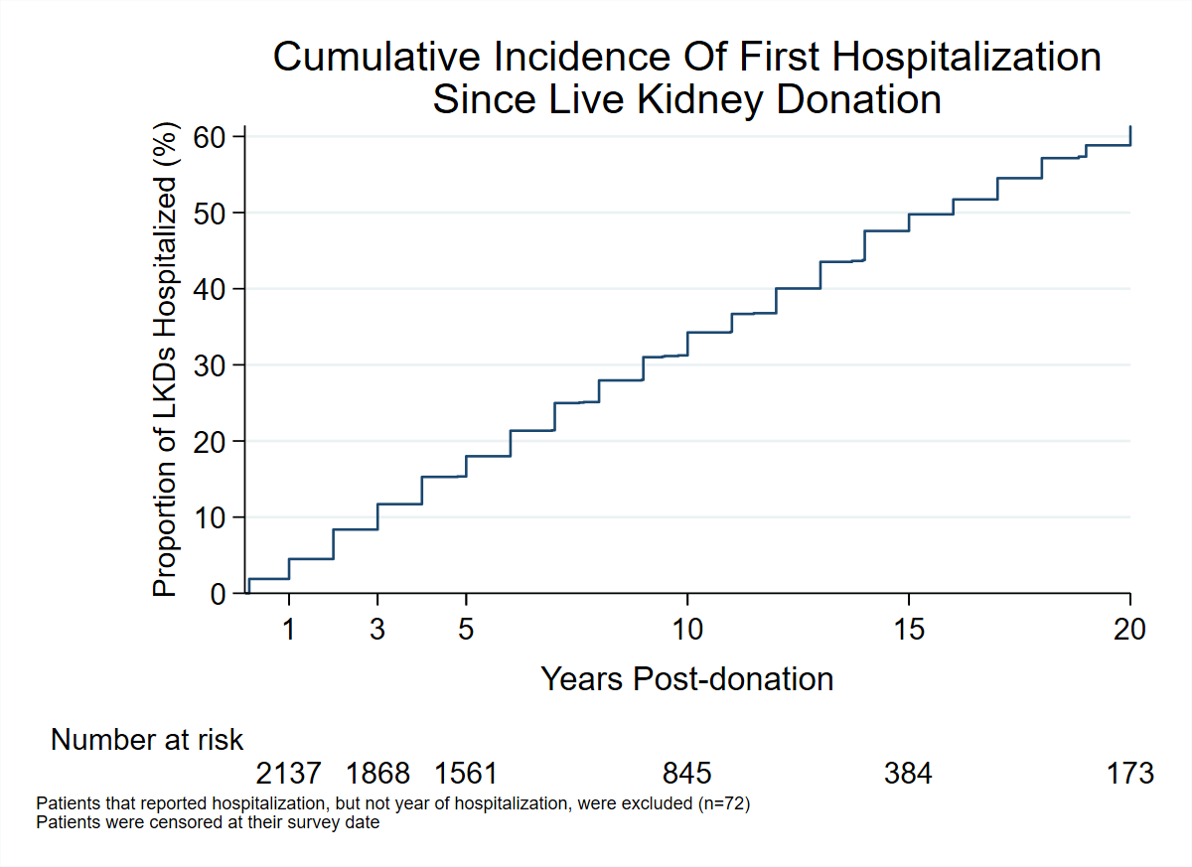

+Patient time-to-event calculated from the date of nephrectomy until the year of self-reported hospitalization or date of survey completion. Month and day of hospitalization were not reported. Thus, a patient was considered to have been hospitalized by 1-year post-donation if they reported hospitalization within a year post-donation.

Figure 2: Multivariable cox proportional hazard model was used to evaluate baseline characteristics association with risk of hospitalization among live kidney donors. Patients that reported hospitalization but did not report the year of hospitalization were excluded (n=72). Patients were followed until the first self-reported hospitalization or survey date.

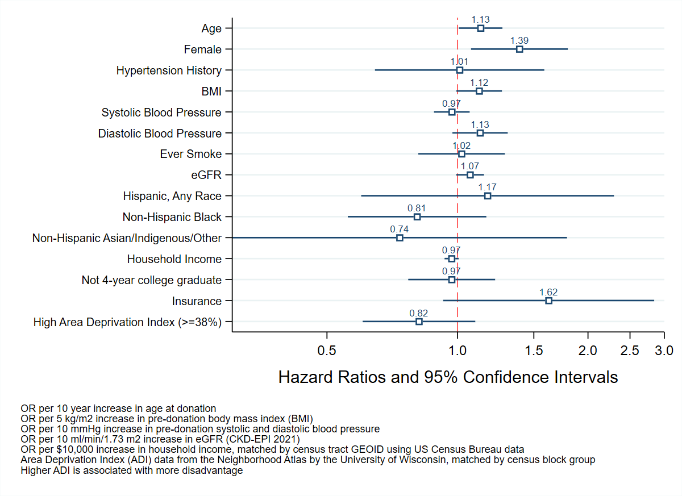

Figure 3: Multivariable cox proportional hazard model was used to evaluate the association of post-donation diabetes or hypertension with hospitalization among live kidney donors, adjusting for baseline characteristics.

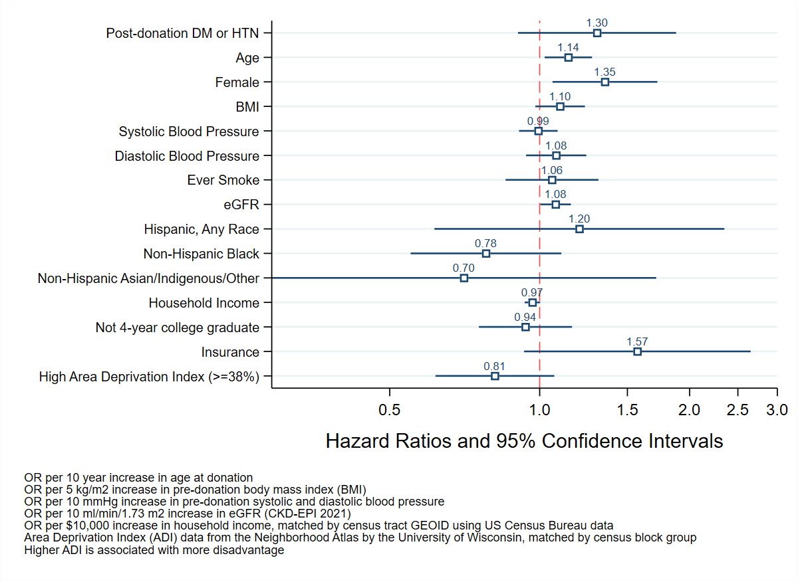

Supplementary Figure 1: Survey content

* Since your donation, have you been admitted to the hospital? *If yes, then the following questions would be asked.*
* How many times were admitted to the hospital? Please list the years when this happened, along with the reason for each admission. *Free text boxes would be available for participants to enter the year and reason for admission.*
* Please indicate whether a doctor or other health care professional has ever diagnosed or treated you for any of the following conditions after your kidney donation: (new conditions that you did not have before you donated your kidney)
  + Chronic/congestive heart failure
  + Coronary artery disease
  + Atherosclerosis
  + Heart attack
  + High blood cholesterol (hyperlipidemia)
  + High blood pressure (hypertension)
  + Stroke (cerebrovascular disease)
  + TIA (Transient ischemic attack)
  + Diabetes

Supplemental Table 1: Demographic and health characteristics of eligible donors who were contacted and completed a survey versus those who did not. Of the 6927 eligible donors, 2251 (33%) responded to the survey and answered the question “Since your donation, have you been admitted to the hospital?”.

|  |  |  |  |
| --- | --- | --- | --- |
| Factor | Survey Non-responders | Survey Responders | p-value |
| N | 4676 | 2251 |  |
| Age at donation, years, median (IQR) | 40 (32, 48) | 46 (38, 54) | <0.001 |
| Female, n (%) | 2515 (60) | 1320 (67) | <0.001 |
| Race, n (%) |  |  | <0.001 |
| Non-Hispanic White | 2881 (68) | 1593 (81) |  |
| Non-Hispanic Black | 1156 (27) | 294 (15) |  |
| Hispanic, any race | 82 (2) | 49 (2) |  |
| Non-Hispanic Indigenous/Asian/Other | 100 (2) | 31 (2) |  |
| Associates/Bachelor’s degree or above, n (%) | 459 (20) | 780 (40) | <0.001 |
| Hypertension, n (%) | 92 (4) | 105 (6) | <0.001 |
| Diabetes, n (%) | 4 (<1) | 5 (<1) | 0.35 |
| BMI, median (IQR), median (IQR) | 27 (24, 30) | 27 (24, 30) | 0.01 |
| Obese, n (%) | 727 (27) | 375 (24) | 0.04 |
| Ever smoke, n (%) | 751 (30) | 593 (30) | 0.92 |
| Serum creatinine, mg/dL, n (%), median (IQR) | 0.85 (0.7-1.0) | 0.8 (0.7-0.99) | <0.001 |
| CKD-EPI (2021), mL/min/1.73m2, median(IQR), median (IQR) | 99 (86, 111) | 95 (83, 107) | <0.001 |

Supplementary Table 2: ICD-10 classification of hospitalization

2375 causes were ascertained using ICD-10 codes.

Xxx to be filled out xxx

Supplemental Figure 2: Venn diagram of unique donors in the parsimonious versus full Cox regression model. *Mutually exclusive

Supplemental Figure 3: Comparing donor characteristic between missing variable versus not missing variable.

|  |  |  |  |
| --- | --- | --- | --- |
|  | Missing variables | Not missing variables | p-value |
|  | n=1081 | n=1063 |  |
| Post-donation Diagnoses of DM or HTN, n (%) | 177 (16) | 155 (15) | 0.25 |
| Age at donation nephrectomy, years, median (IQR) | 45 (37, 53) (n=1081) | 48 (39, 56) (n=1063) | <0.001 |
| Female, n (%) | 699 (65) | 728 (68) | 0.061 |
| Race, n (%) |  |  | 0.64 |
| Non-Hispanic White | 869 (80) | 872 (82) |  |
| Hispanic, Any Race | 30 (3) | 31 (3) |  |
| Non-Hispanic Black | 159 (15) | 136 (13) |  |
| Non-Hispanic Other | 23 (2) | 24 (2) |  |
| Ever smoke, n (%) | 454 (42) | 384 (36) | 0.005 |
| BMI, kg/m2, median (IQR) | 27 (24, 30) (n=435) | 27 (24, 30) (n=1063) | 0.73 |
| Systolic BP, mmHg, median (IQR) | 123 (113, 133) (n=316) | 124 (114, 132) (n=1063) | 0.60 |
| Diastolic BP, mmHg, median (IQR) | 74 (68, 80) (n=316) | 73 (68, 80) (n=1063) | 0.81 |
| eGFR, median (IQR) | 96 (83, 109) (n=559) | 95 (83, 106) (n=1063) | 0.45 |
| Not 4 year college-educated | 503 (47) | 414 (39) | <0.001 |
| Have AT donation insurance | 968 (92) | 995 (94) | 0.23 |
| Disadvantaged Area Deprivation Index (>=38 Median) | 366 (54) | 511 (48) | 0.016 |
| Years between donation and last survey | 15 (8, 21) | 8 (6, 12) | <0.001 |

WORD GRAVEYARD

There were a few statistically significantly different characteristics between LKDs who reported hospitalization versus those who did not. Most notably, LKDs who reported hospitalization were more likely to be female (69% vs 65%, p=0.03), diabetic (0% vs 1%, p=0.01), smoker (42% vs 38%, p=0.03), with a higher median BMI (27 vs 26 kg/m2, p=0.04). In terms of social history, they were also more likely to have a lower income ($79,099 vs $83,580, p<0.01), high ADI (54% vs 47%, p<0.01), yet less likely to be college-educated (53% vs 60%, p<0.01) (Table 2). Age, race/ethnicity, hypertension history, eGFR, systolic and diastolic blood pressure, and insurance status were not significantly different between the two groups.

|  |  |  |  |
| --- | --- | --- | --- |
| Table 2. Comparing baseline demographic, health, and socioeconomic characteristics of live kidney donors among LKDs who were hospitalized versus never hospitalized. | | | |
|  | Never Hospitalized n=1313 | Hospitalization n=938 | p valuea |
| Age, y, median (IQR) | 47 (38,55) | 47 (37,55) | 0.92 |
| Female, % | 65 | 69 | 0.03 |
| Race/Ethnicity |  |  | 0.07 |
| Nonhispanic White, % | 80 | 83 |  |
| Hispanic (any race), % | 3 | 2 |  |
| Nonhispanic Black, % | 14 | 14 |  |
| Nonhispanic Other, % | 3 | 2 |  |
| Hypertension History, % | 5 | 6 | 0.53 |
| Diabetes History, % | 0 | 1 | 0.01 |
| BMI, kg/m2, median (IQR) | 26 (24,30) | 27 (24-30) | 0.04 |
| Systolic BP, mmHg, median (IQR) | 123 (114,132) | 124 (114-133) | 0.43 |
| Diastolic BP, mmHg, median (IQR) | 73 (68,80) | 73 (68,80) | 0.31 |
| eGFR, mL/min/1.73m2, median (IQR) | 83 (69,102) | 85 (69,103) | 0.49 |
| Ever Smokeb, % | 38 | 42 | 0.03 |
| Had Insurance, % | 93 | 93 | 0.45 |
| Four Year Bachelor or above, % | 60 | 53 | <0.01 |
| Household Income, USD, median (IQR) | 83580 (62375- 117182) | 79099 (58899-108205) | <0.01 |
| Area Deprivation Index, %, median (IQR) | 35 (18-59) | 42 (22-62) | <0.01 |
| Area Deprivation Index ≥38%, % | 47 | 54 | <0.01 |
| a Categorical and continuous variables were analyzed using Pearson’s chi-square and Wilcoxon rank-sum (2 groups) test. Age <1 vs <1% missing  Sex <1 vs <1% missing  Race/ethnicity 4 vs 5% missing  Hypertension history 20 vs 28% missing  Diabetes history 20 vs 30% missing  BMI 23 vs 39% missing  Systolic blood pressure 29 vs 44% missing  Diastolic blood pressure 29 vs 44% missing  Serum creatinine/eGFR 20 vs 30% missing  Ever Smoke <1 vs <1% missing  Insurance status 4 vs 7% missing  Education level <1 vs <1% missing  Area deprivation index 20 vs 18% missing | | | |

Say something about socioeconomic and racial factors